### A CRM APPLICATION FOR LAPTOP RENTALS

## 1. Project Overview

The Laptop Rentals CRM Application is a robust solution designed to streamline and optimize the daily operations of a laptop rental business. The primary objective is to efficiently manage laptop inventory, rental transactions, and customer interactions while providing insightful reports to key stakeholders. This project utilizes Salesforce's capabilities, including custom objects, workflows, and dashboards, to enhance operational efficiency, improve customer satisfaction, and ensure data accuracy.

Through this project, we aim to provide a centralized platform for managing and analyzing rental operations, enabling the organization to make data-driven decisions and achieve sustainable growth.

Key aspects of the project include automated workflows, role-based access control, and real-time data visualization, all tailored to the specific needs of a laptop rental business.

## 2. Objectives

Business Goals:

* Improve the efficiency of laptop rental operations.
* Enhance customer experience with personalized services and seamless transactions.
* Generate actionable insights into inventory and revenue trends.

Technical Goals:

* Create custom Salesforce objects for managing laptops, rentals, and customers.
* Implement dashboards and reports to monitor key metrics.

**3. Salesforce Key Features and Concepts Utilized**

The **Laptop Rentals CRM Application** leverages Salesforce’s robust features and concepts to streamline the management of customer interactions, rental processes, and business operations. Below are the key features and concepts utilized in the project:

**Salesforce Objects**

* + **Standard Objects:** Objects like Accounts, Contacts, and Cases were used to manage customer data, track interactions, and address support requests.
  + **Custom Objects:** All Laptop Rentals objects were created to manage inventory, rental agreements, and transaction history specific to laptop rentals.

**Automation Tools**

* + **Process Builder:** Automated workflows were set up to send reminders for rental due dates, initiate follow-ups, and update status fields.
  + **Flow Builder:** Complex logic was implemented to automate rental request approvals and inventory management processes.
  + **Email Alerts:** Notifications were automated for both customers (e.g., rental confirmations) and staff (e.g., low stock alerts).

**Service Cloud Features**

* + **Case Management:** Used to handle customer inquiries, complaints, and service requests, ensuring timely resolutions.
  + **Knowledge Base:** A repository of FAQs and troubleshooting guides was set up to assist customers and agents with common queries.

**Sales Cloud Features**

* + **Opportunity Management:** Opportunities were used to track potential rental agreements and upselling of additional services (e.g., extended warranties).
  + **Lead Conversion:** Captured customer leads through forms and converted them into rental accounts seamlessly.

**Reports and Dashboards**

* Created custom reports to track metrics such as the number of active rentals, total revenue, and inventory usage.
* Dashboards provided real-time insights for the management team to monitor operations and identify trends.

**Security Features**

* + **Role Hierarchy and Sharing Rules:** Ensured that sensitive data, such as rental contracts and payment details, was accessible only to authorized personnel.
  + **Field-Level Security:** Restricted visibility of confidential fields like payment details.

**Integration Capabilities**

* + Integrated with third-party payment gateways for seamless online payments.
  + Synced with inventory management systems to ensure real-time availability of laptops.

## 4. Detailed Steps to Solution Design

### Creating Developer Account:

1. Visit [Salesforce Developer Signup](https://developer.salesforce.com/signup).
2. Fill in the required details: Name, Email, Role (Developer), Company, and Username (e.g.username@organization.com).
3. Verify the account through the email received and set up your password.

### Object Creation

### Create Total Laptops Object

From the setup page >> Click on Object Manager >> Click on Create >> Click on Custom Object.

1) Enter the label name>> Total Laptops

2) Plural label name>> Total Laptops

3) Enter Record Name Label and Format

Record Name >>Total Laptops

Data Type >> Text

Click on Allow reports,Allow search and Track Field History,

Allow search >> Save.

### Create Consumer Object

From the setup page >> Click on Object Manager >> Click on Create >> Click on Custom Object.

1) Enter the label name >> consumer

2) Plural label name >> consumer

3) Enter Record Name Label and Format

Record Name >> consumer_name

Data Type >> Name

Click on Allow reports,Allow search and Track Field History,

Allow search >> Save.

Create Laptop Bookings Object

From the setup page >> Click on Object Manager >> Click on Create >> Click on Custom Object.

1) Enter the label name >> Laptop Bookings

2) Plural label name >> Laptop Bookings

3) Enter Record Name Label and Format

Record Name >> Laptop Bookings

Data Type >> Name

Click on Allow reports,Allow search and Track Field History,

Allow search >> Save.

Create Billing Process Object

From the setup page >> Click on Object Manager >> Click on Create >> Click on Custom Object.

1) Enter the label name >> Billing Process

2) Plural label name >> Billing Process

3) Enter Record Name Label and Format

Record Name >> Billing ProcessName

Data Type >> Name

Click on Allow reports,Allow search and Track Field History,

Allow search >> Save.

### Tabs

### Creating a Custom Tab

1. Go to setup page >> Type Tabs in Quick Find bar >> click on tabs >> New (under custom object tab)

2. Select Object(Total Laptops) >> Select the tab style >> Next (Add to profiles page) keep it as default >> Next (Add to Custom App) uncheck the include tab .

3. Make sure that the Append tab to users' existing personal customizations is checked.

4. Click save.

## Creating Remaining Tabs

Now create the Tabs for the remaining Objects, they are “consumer,Laptop Booking,Billing process”.

Follow the same steps as mentioned in custom tab.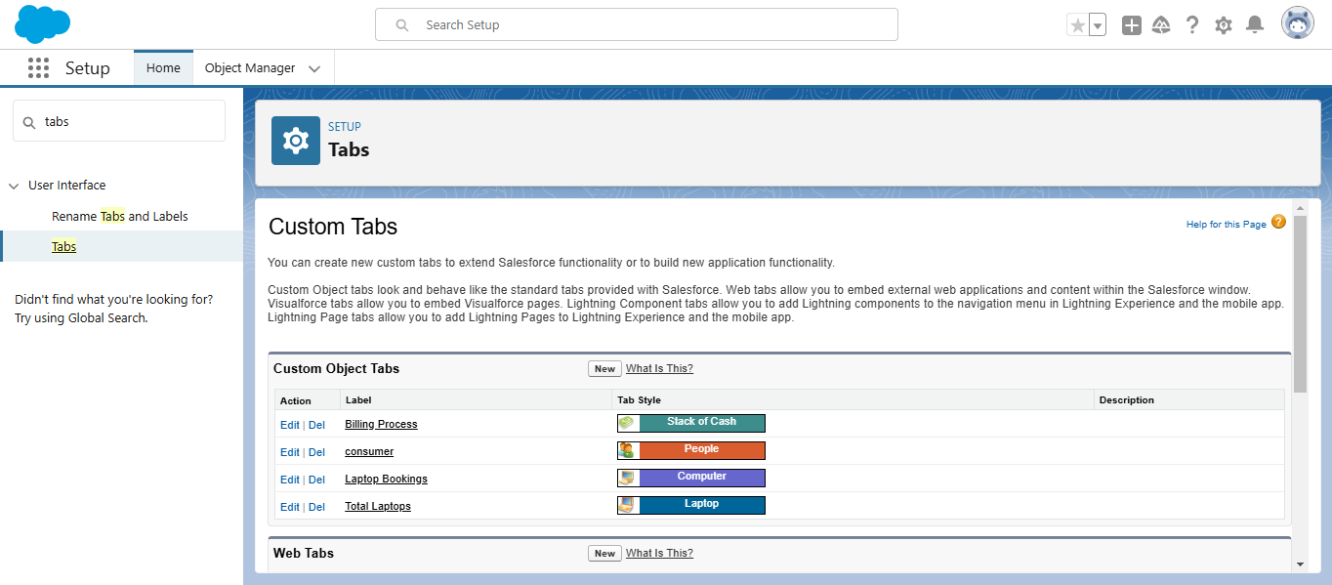

The Lightning App

### Create a Lightning App

1. Go to setup page >> search “app manager” in quick find >> select “app manager” >> click on New lightning App.

2. Fill the app name in app details as LAPTOP RENTALS >>Next >> (App option page) keep it as default >> Next >> (Utility Items) keep it as default >> Next.

3. Upload a photo that is related to your app.

4. To Add Navigation Items: Select the items (Total Laptops,consumer,Laptop Booking,Billing Process) from the search bar and move it using the arrow button >> Next.

5. To Add User Profiles: Search profiles (System administrator) in the search bar >> click on the arrow button >> save & finish.

Fields

Creating the field in Consumer Object

**1. To create fields in an object:**

1. Go to setup >> click on Object Manager >> type object name(consumer) in search bar >> click on the object.

2. Now click on “Fields & Relationships” >> New

3. Select Data Type as a “Phone”

4. Click on next

5. Fill the Above as following:

Field Label: Phone number

Field Name : gets auto generated

Click the required option checkbox.

Click on Next >> Next >> Save and new.

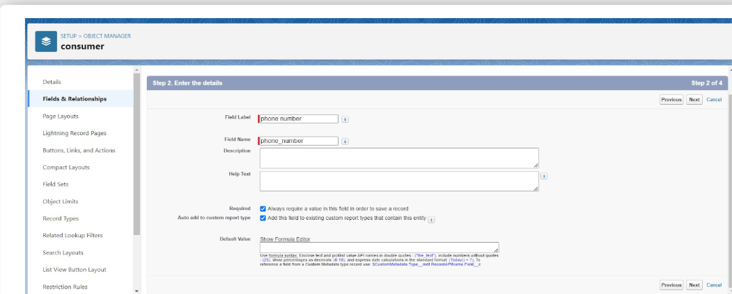

**2. To create another fields in an object:**

1. Go to setup >> click on Object Manager >> type object name(consumer) in search bar >> click on the object.

2. Now click on “Fields & Relationships” >> New

3. Select Data type as a “Email” and Click on Next

4. Fill the Above as following:

Field Label: Email

Field Name :It’s gets auto generated

Click on Next >> Next >> Save and new.

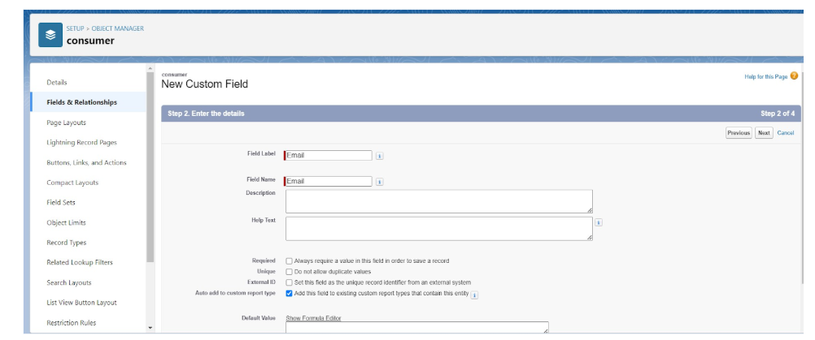

**3. To create another fields in an object:**

1. Go to setup >> click on Object Manager >> type object name(consumer) in search bar >> click on the object.

2. Now click on “Fields & Relationships” >> New

3. Select Data type as a “Text Area” and Click on Next

4. Fill the Above as following:

Field Label: Address

Field Name : It’s gets auto generated

Select Required field.

Click on Next >> Next >> Save and new.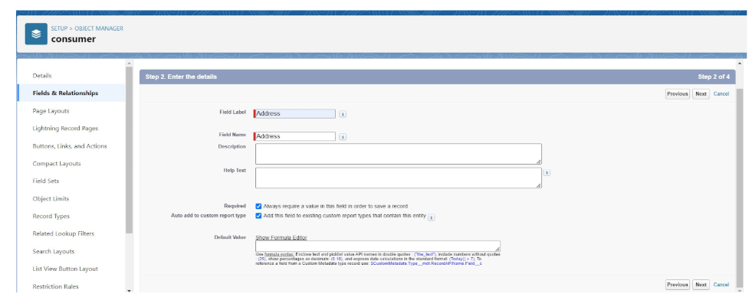

**4. To create another fields in an object:**

1. Go to setup >> click on Object Manager >> type object name(consumer) in search bar >> click on the object.

2. Now click on “Fields & Relationships” >> New

3. Select Data type as a “Picklist” and Click on Next

4. Fill the Above as following:

Field Label: consumer Status

Value - Select enter values with each value separated by a new line

Student

Employee

Others

Select required

Field Name :It’s gets auto generated

Click on Next >> Next >> Save and new.

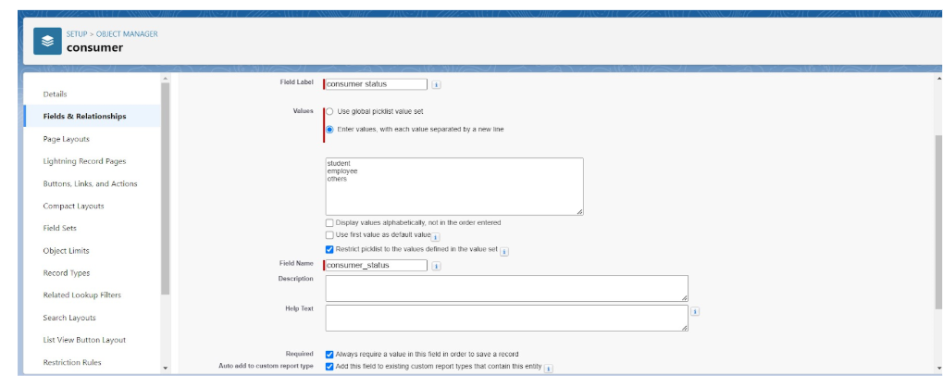

Creating the field in Laptop Bookings Object

**1. To create fields in an object:**

1. Go to setup >> click on Object Manager >> type object name(Laptop Booking) in the search bar >> click on the object.

2. Now click on “Fields & Relationships” >> New

3. Select Data Type as a “Picklist”

Label: Laptop Names

Picklist values are:-1.Dell 2. Acer 3.Hp 4.Mac

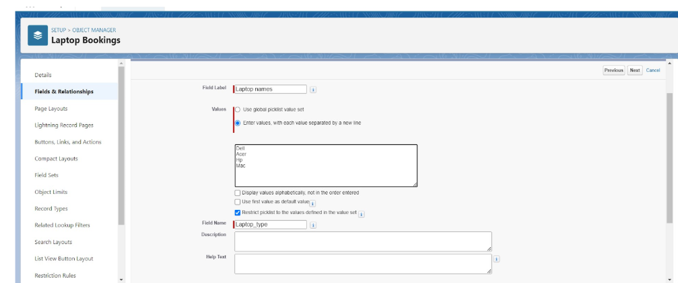

4.Select required

5.Click on Next >> Next >> Save and new

2.**To Create a Fields & Relationship to an Laptop Booking Object**

To create fields & relationship to an object:

1.Go to setup >> click on Object Manager >> type object name(Laptop Booking) in the search bar >> click on the object.

2.Now click on “Fields & Relationships” >> New

3.Select Data Type as a “Picklist” and Label: Core Type

4.Picklist values are:-1.core i3 2. Core i5 3. Core i7 4.Bionic Chip

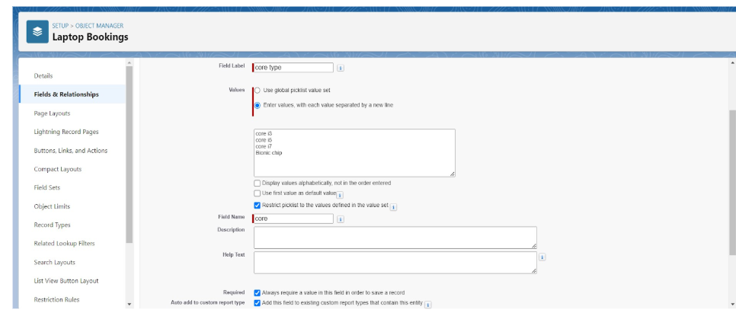

5.Select required

6.Click on Next >> Next >> Save and new

**3.To Create a Field Dependency in the Laptop Booking Object**

To create field dependency to an object:

1.Go to setup >> click on Object Manager >> type object name(Laptop Booking) in the search bar >> click on the object.

2.click field dependency and next

3. Select Controlling Field as Laptop Names and Dependent Field as Core Type

4. Click the include value for dell-core i3,i5,i7 and for acer i3,i5,i7 and for hp i3,i5,i7 and also for mac bionic chip include the values for it.

Click save.

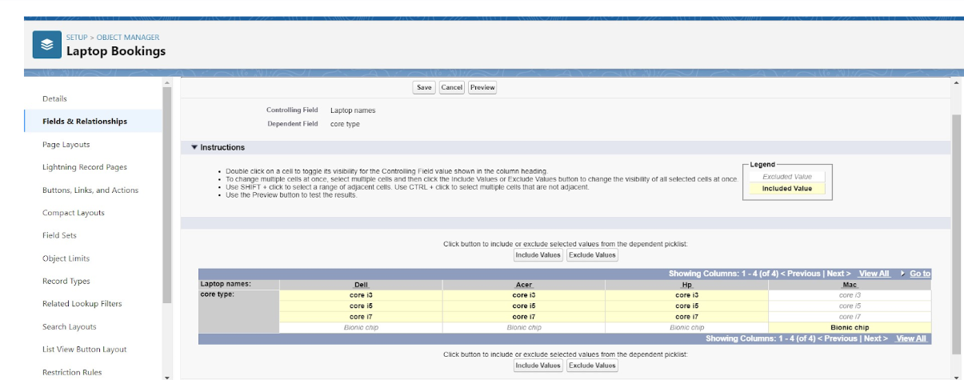

To Create a Fields & Relationship to a Laptop Booking and Total Laptops Objects

**1.To create fields & relationship to an object:**

1.Go to setup >> click on Object Manager >> type object name(Laptop Booking) in the search bar >> click on the object.

2.Now click on “Fields & Relationships” >> New

3.Select Data Type as a “Master-Detail Relationship”

4.Click on Next

5.Click on the Related to drop down and Select the “consumer” object and click on Next

6.Fill the Above as following:

Change the Field Label: Consumer

Field Name :It’s gets auto generated

7.Click on Next >> Next >> Save and new.

**2.To create fields in an object:**

1.Go to setup >> click on Object Manager >> type object name(Laptop Booking) in the

2.search bar >> click on the object.

3.Now click on “Fields & Relationships” >> New

4.Select Data Type as a “Currency”

5.Click on Next

Fill the Above as following:

Field Label: Amount, Length: (18,0), Field Name :It’s gets auto generated

Click on Next >> Next >> Save and new

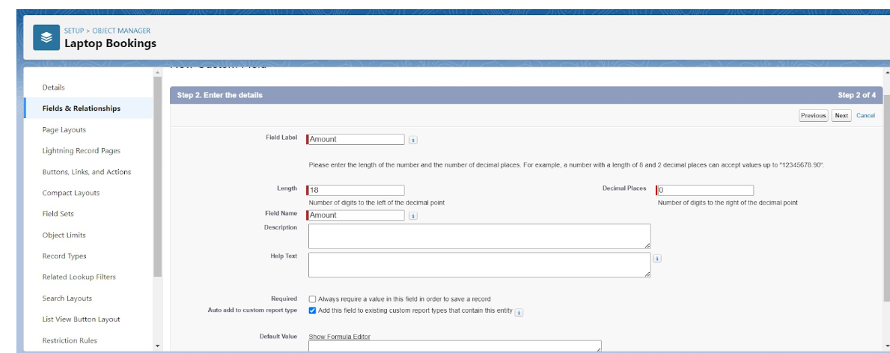

**3.To Create a Fields & Relationship to an Object**

1.Go to setup >> click on Object Manager >> type object name(Laptop Booking) in the search bar >> click on the object.

2.Now click on “Fields & Relationships” >> New

3.Select Data Type as a “Lookup Relationship”

4.Click on Next

5.Click on the Related to drop down and Select the “Total Laptops” object and click on Next

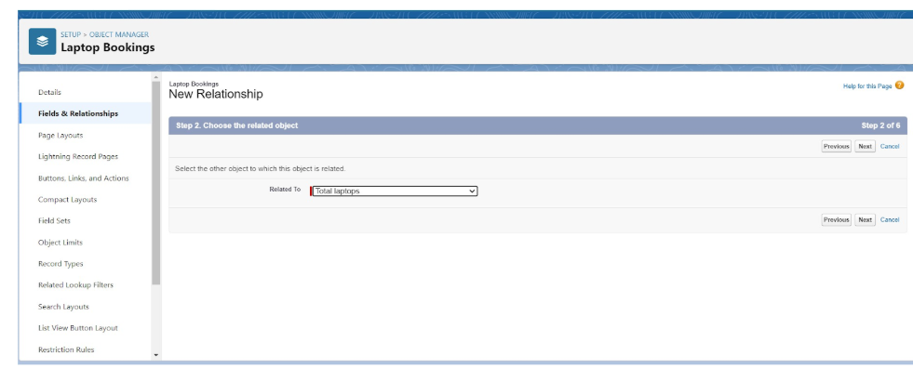

6.Fill the Above as following:

Change the Field Label: Total No Of Laptops, Field Name :It’s gets auto generated

7.Click on Next >> Next >> Save and new.

**To Create a Fields & Relationship to an Laptop Booking Object**

To create fields & relationship to an object:

8.Go to setup >> click on Object Manager >> type object name(Laptop Booking) in the search bar >> click on the object.

9.Now click on “Fields & Relationships” >> New

10.Select Data Type as a “Email”, Click on Next and save it.

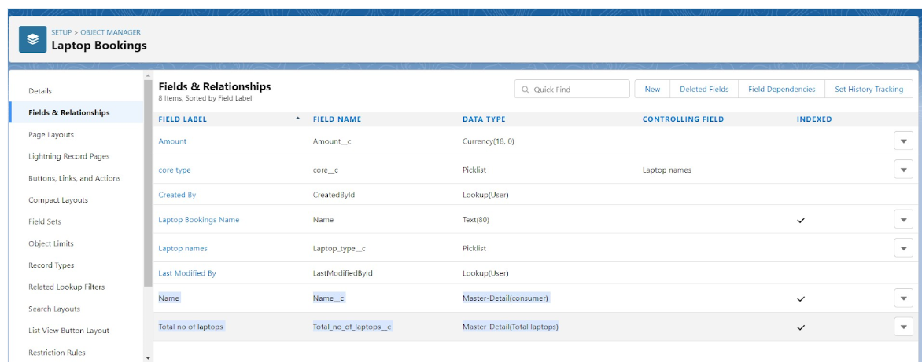

**5.To Create a Rollup Summary Field in “Total Laptops Object”**

1.After Creating the Master-Detail Relationship Than Only you can create the Rollup Summary

2.Go to setup >> click on Object Manager >> type object name(Total Laptops) in the search bar >> click on the object.

3.Now click on “Fields & Relationships” >> New

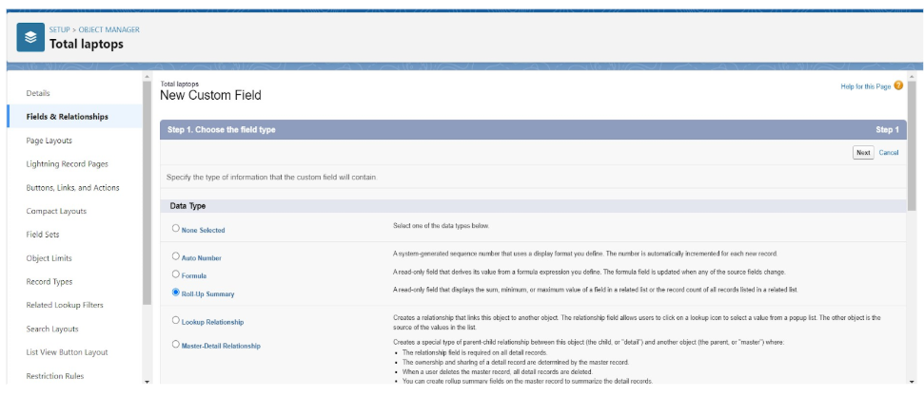

4.Select Data type as a “Roll-up Summary” and Click on Next

Fill the Above as following:

* Field Label: Laptops delivered, Field Name :It’s gets auto generated, Click on Next

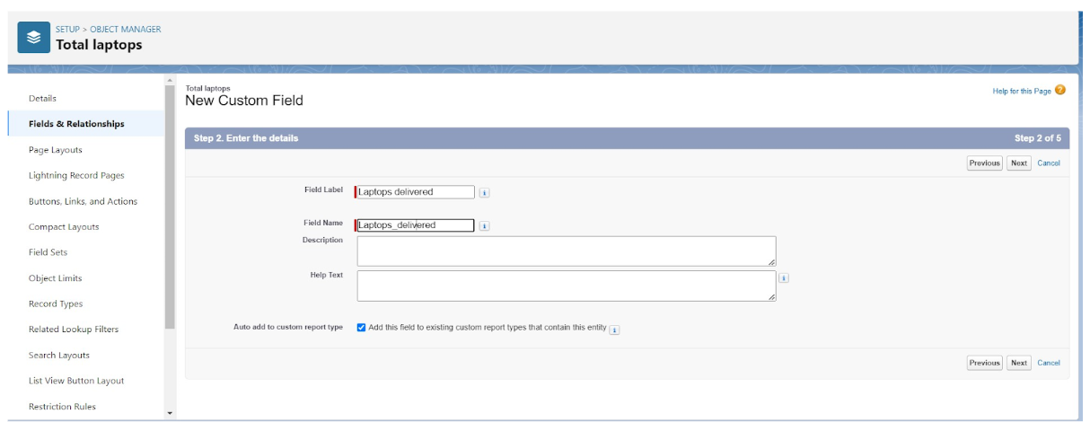

6.Select the Laptop Bookings in the Summarized Object

7.Select the count Radio button in the select Roll-up Type

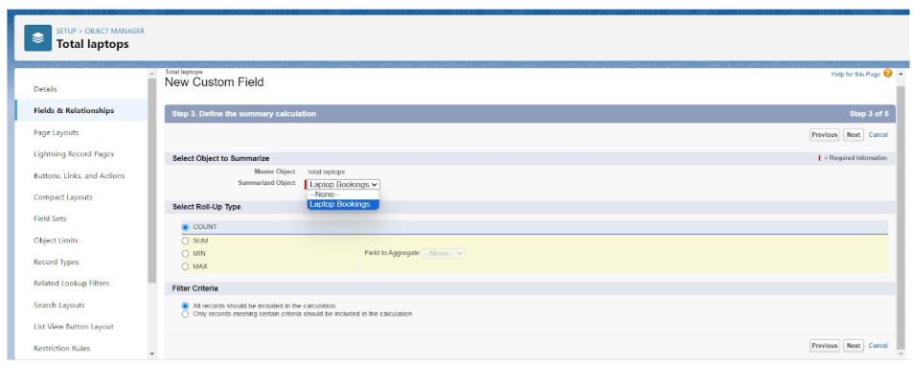

**To create fields in an object:**

1.Go to setup >> click on Object Manager >> type object name(Laptop Booking) in the search bar >> click on the object.

2.Now click on “Fields & Relationships” >> New

3.Select Data type as a “Formula” and Click on Next

4.Fill the Above as following:

Field Label: Laptops Available

Field Name : It’s gets auto generated

5.Select the Formula Return Type as “Number”

6.Select the Decimal places as “0” and Click on Next

7.Click on the Advanced Formula and Enter the value in formula box “ 50 - ” and Click on insert field than you will find a pop window under the Laptop Booking select the Total No Of Laptops in the second Column and select the Laptops delivered in the third column and click on insert“ 50 - Total_no_of_laptops__r.Laptops_delivered__c ” and Check Syntax

Click on Next >> Next >> Save and new

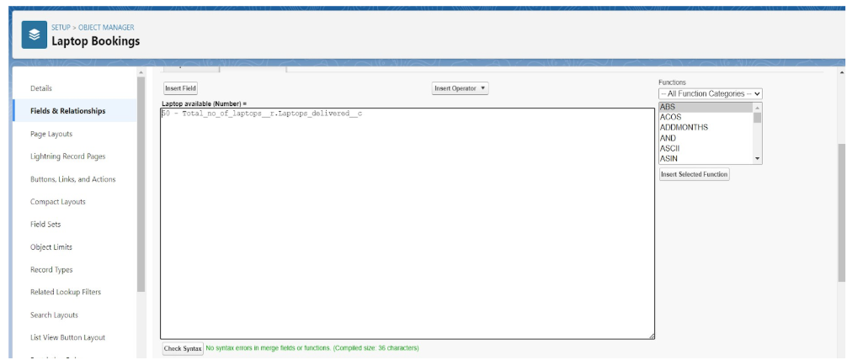

**To create fields in an object:**

1.Go to setup >> click on Object Manager >> type object name(Laptop Booking) in the 2.search bar >> click on the object.

3.Now click on “Fields & Relationships” >>New

4.Select Data Type as a “picklist” and Label: how many months

Picklist values are 1.2.3.4.5

Click and save it.

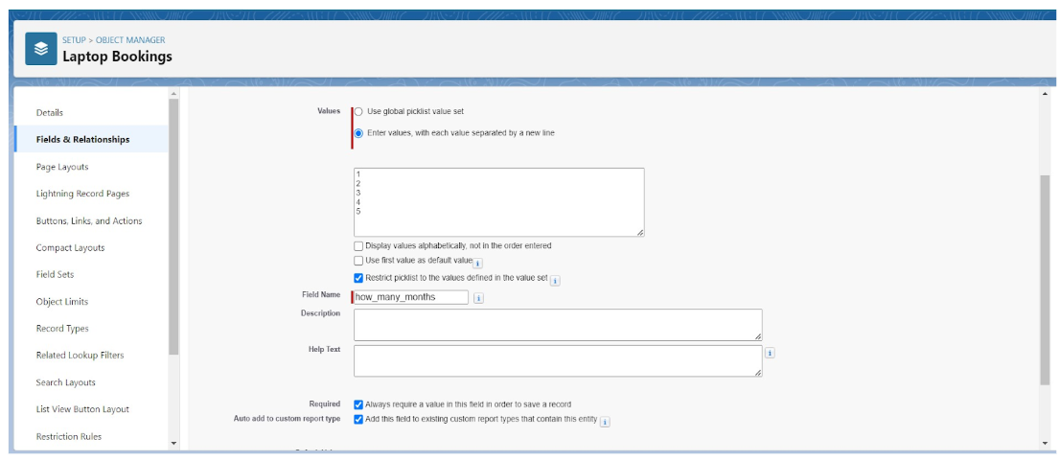

Creation of Fields & Relationship for Billing Process

1.**To create fields & relationship to an object:**

1.Go to setup >> click on Object Manager >> type object name(Billing Process) in the search bar >> click on the object.

2.Now click on “Fields & Relationships” >> New

3.Select Data Type as a “Master-detail Relationship”

4.Click on Next

5.Click on the Related to drop down and Select the consumer object and click on Next

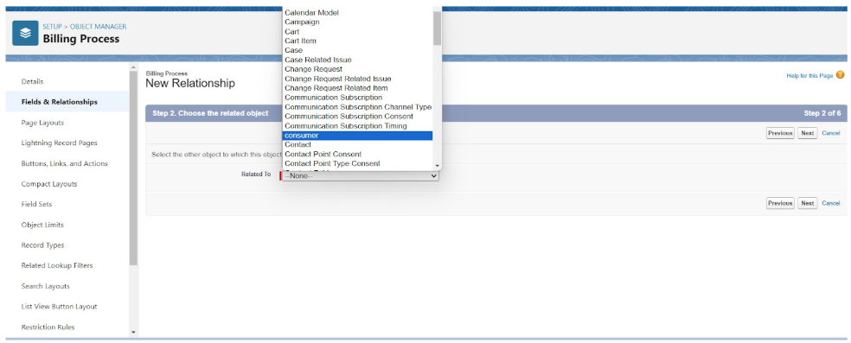

Fill the Above as following:

Change the Field Label: Name

Field Name :It’s gets auto generated

Click on Next >> Next >> Save and new.

2.**To create another fields & relationship to an object:**

1.Go to setup >> click on Object Manager >> type object name(Billing Process) in the search bar >> click on the object.

2.Now click on “Fields & Relationships” >> New

3.Select Data Type as a “Lookup Relationship”

4.Click on Next

5.Click on the Related to drop down and Select the Laptop Booking object and click on Next

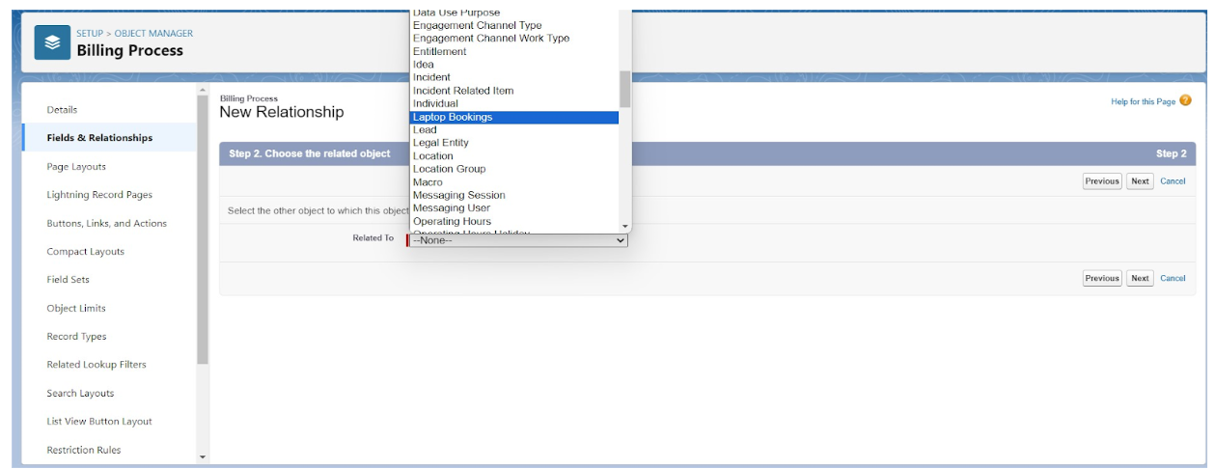

6.Fill the Above as following:

Change the Field Label: Laptop Booking

Field Name :It’s gets auto generated

Click on Next >> Next >>Save and new.

**3.Creation of another fields for the billing process objec**t

To create fields in an object:

1.Go to setup >> click on Object Manager >> type object name(Billing Process) in the search bar >> click on the object.

2.Now click on “Fields & Relationships” >> New

3.Select Data Type as a “Picklist”

4.Fill the Above as following:

Field Label: Payment Mode

Value >> Select enter values with each value separated by a new line

Cash

Check

Credit card

Debit card

UPI

Phonepe

Gpay

Paytm

Select required

Click on Next >> Next >> Save and new.

**4.Create a Cross object formula Field in billing process Object**

1.Go to setup >> click on Object Manager >> type object name(Billing Process) in the search bar >> click on the object.

2.Now click on “Fields & Relationships” >> New

3.Select Data Type as a “Formula”

4.Click on Next

5.Enter the Field label: Amount, the Field name gets auto generated and click on Next.(Formula return type Currency).

6.In the Advanced Formula Click on the Insert field in the popup Screen Select the Billing Process and in the second drop down select the Laptop Booking and in the three drop down select the Amount field and click on Insert “ Laptop_Booking__r.Amount__c ”.

7.Click on the Check syntax: No syntax errors in merge fields

8.Click on Next >> Next >> Save and new.

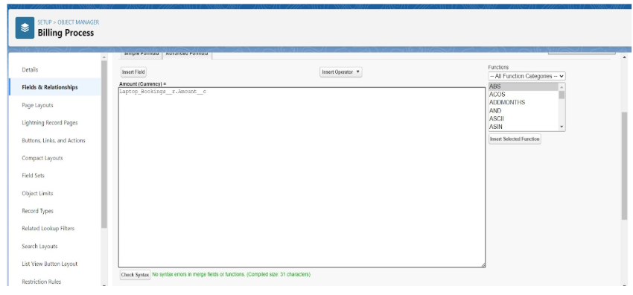

### Creating the field in Total Laptops object

**1.To create fields in an object:**

1.Go to setup >> click on Object Manager >> type object name(Total Laptops) in search bar >> click on the object.

2.Now click on “Fields & Relationships” >> New, Select Data type as a “Formula” and Click on Next. Field Label: Laptops Available, Field Name : It’s gets auto generated

3.Select the Formula Return Type as “Number”,Select the Decimal places as “0” and Click on Next

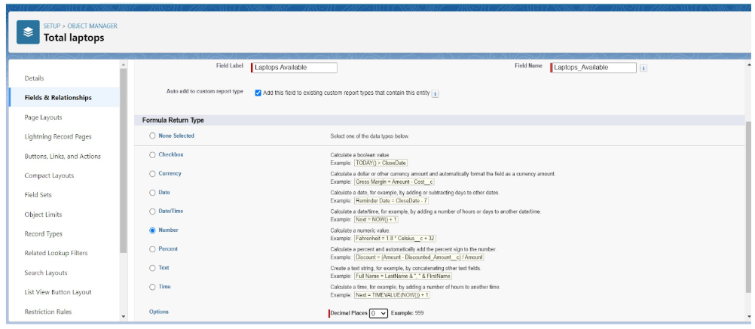

**Note: I am Considering “Total No Of Laptops = 50” While creating a new record in Total Laptops Object.**

Click on the Advanced

Formula “ 50 - Laptops_delivered__c ” and Check Syntax

Click on Next >>Next >>Save and new.

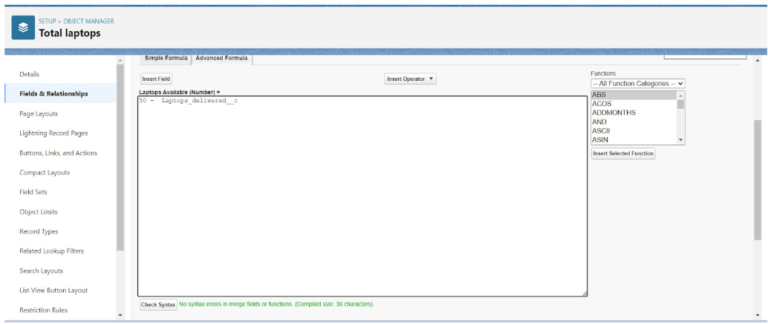

Validation Rule

Creating the validation rule for phone number field in customer object

**Creating the validation rule for phone number field in consumer object**

1.Go to the setup page >> click on object manager >> From drop down click edit for consumer object.

2.Click on the validation rule >> click New.

3.Enter the Rule name as “Phonenumberoremailblankrule ”.

4.Enter the description as “phone number and email number should not be blank”.

5.Enter the formula as “OR( ISBLANK( phone_number__c ) , ISBLANK( email__c ) )” and check the syntax.

6.Save the validation rule.

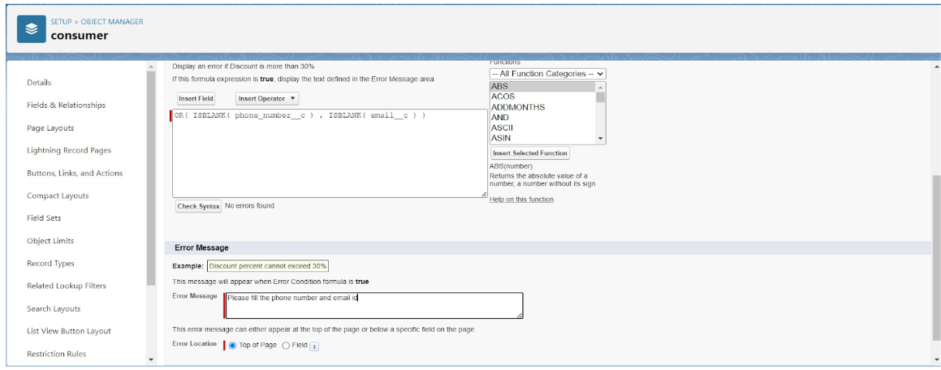

Profiles

Owner Profile

To create a new profile:

1.Go to setup >> type profiles in quick find box >> click on profiles >> clone the desired profile (Standard User) >> enter profile name (owner) >> Save.

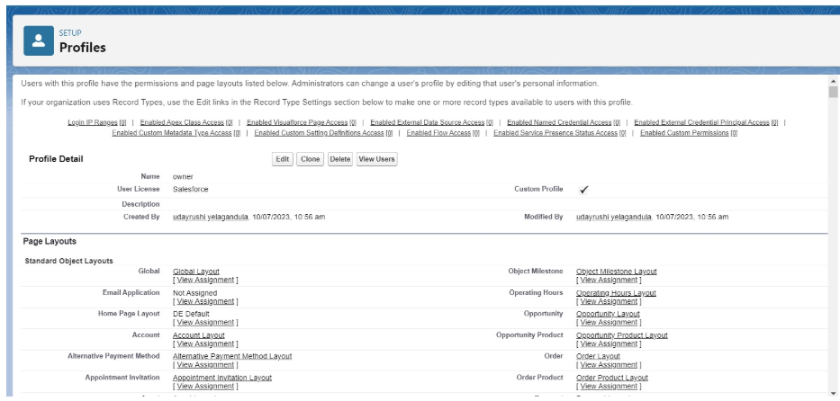

2.Scroll down to Custom Object Permissions and Give access permissions for Total Laptops, consumers , Laptop Booking and Billing Process objects as mentioned in the below diagram.

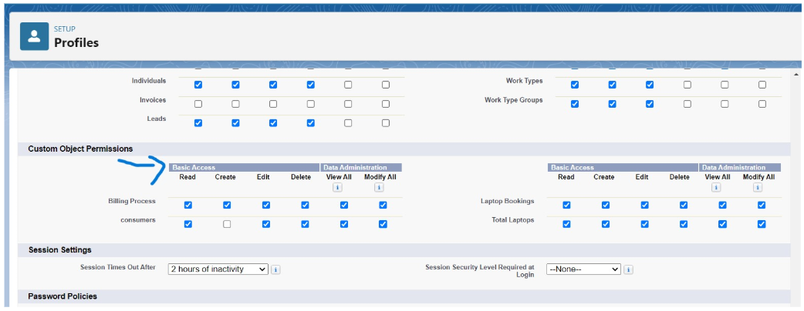

3.Give Access and Save it.

Agent Profile

1.Go to setup >> type profiles in quick find box >> click on profiles >> clone the desired profile (Standard Platform User) >> enter profile name (Agent) >>Save.

2.While still on the profile page, then click Edit.

3.Scroll down to Custom Object Permissions and Give access permissions for Total Laptops, consumer , Laptop Bookings and Billing Process objects as mentioned in the below diagram.

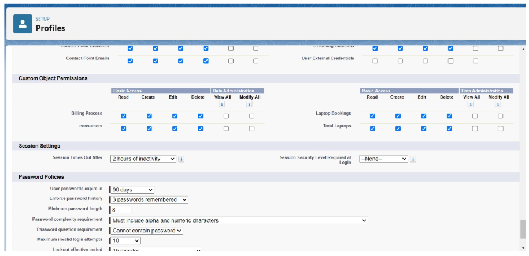

4.Give access and save it.

Roles and Hierarchy

Creating Owner Role

Creating owner Role:

1.Go to quick find >> Search for Roles >> click on set up roles.

2.Click on Expand All and click on add role under whom this role works.

3.Give Label as “owner” and Role name gets auto populated. Then click on Save.

4.Click and Save it.

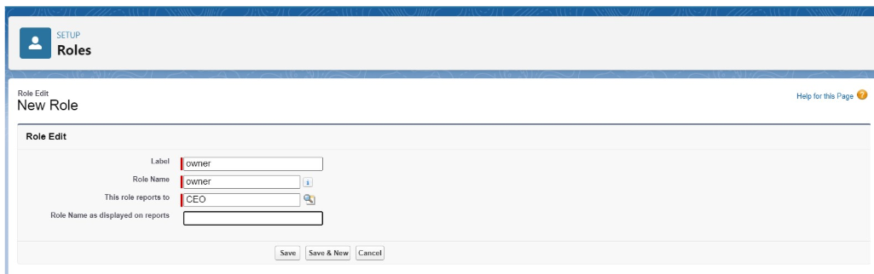

Creating Agent Role

Creating another two roles under Owner

1.Go to quick find - Search for Roles - click on set up roles.

2.Click plus on CEO role, and click add role under owner.

3.Give Label as “Agent” and Role name gets auto populated. Then click on Save.

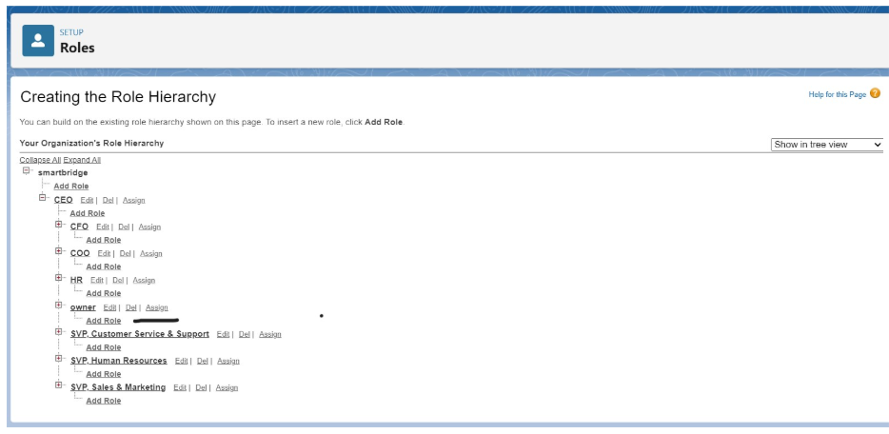

Users

Create User

1.Go to setup - type users in quick find box - select users -click New user.

2.Fill in the fields

3.First Name : vicky

4.Last Name : y

5.Alias : Give a Alias Name

6.Email id : Give your Personal Email id

7.Username : Username should be in this form: text@text.text

8.Nick Name : Give a Nickname

9.Role : owner

10.User license : Salesforce

11.Profiles : owner

12.Save it

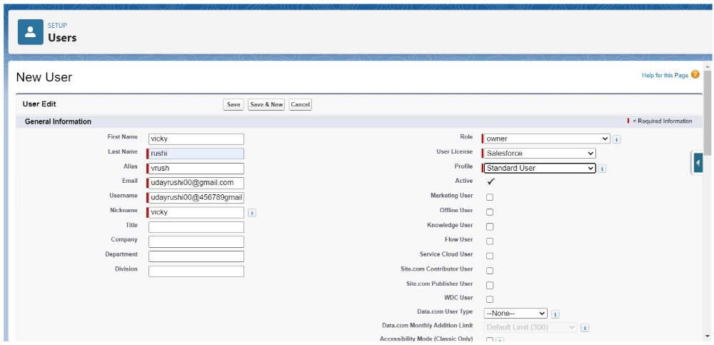

**creating another users**

1.Go to setup -type users in quick find box - select users -click New user.

2.Fill in the fields

3.First Name : ram

4.Last Name : ram

5.Alias : Give a Alias Name

6.Email id : Give your Personal Email id

7.Username : Username should be in this form: text@text.text

8.Nick Name : Give a Nickname

9.Role : Agent

10.User license : Salesforce platform

11.Profiles : Agent.

12.Save it.

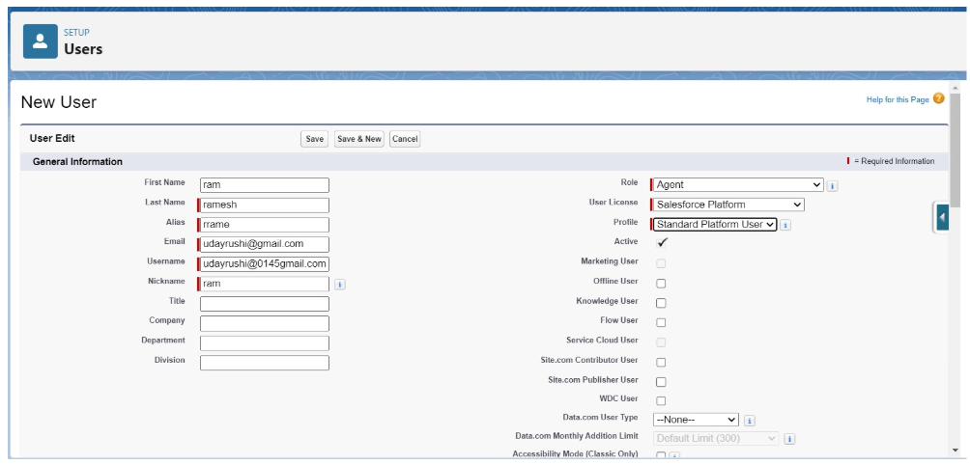

Flows

### Create a Flow on dell laptop

1.Go to setup >>type Flow in quick find box >> Click on the Flow and Select the New Flow.

2.Select the Record-triggered flow and Click on Create. Select the Object as a Laptop Booking in the Drop down list. Select the Trigger Flow when: “A record is Created or Updated”.Select the Optimize the flow for: “Actions and Related Records” and Click on Done.

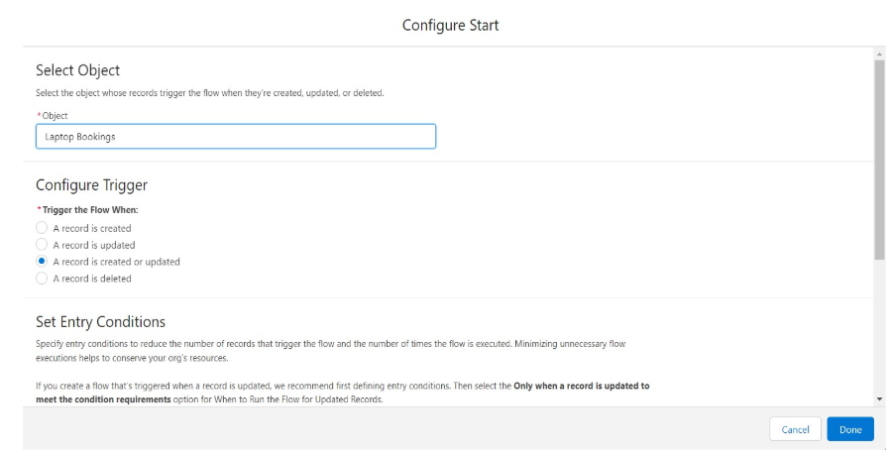

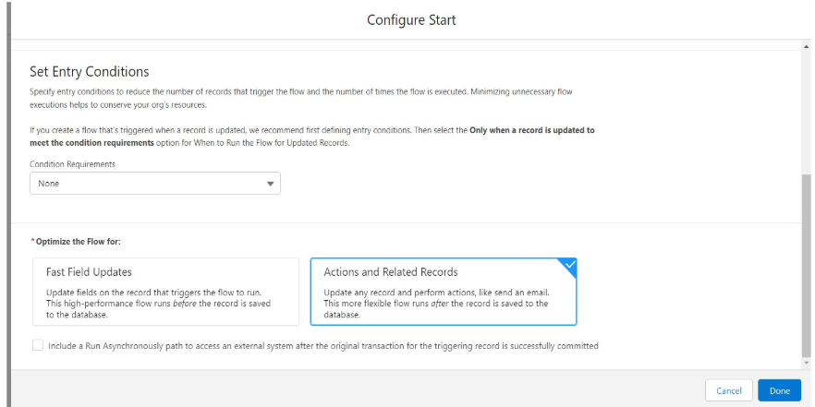

3.Under the Record-triggered Flow Click on “+” Symbol and In the Drop down List select the “Decision Element”.

4.Enter the Details Label: Field should be Update, API name: Gets Automatically Generated.

5.Enter the Outcome Details Label: dell , Outcome API name: Gets Automatically Generated.

6.Resource: Select $Record.Laptop_name__c., Operator: Select Equals., Value: Select dell

7.Add the same outcome order to acer , hp, mac.

8.Rename Default outcome as False, Click done.

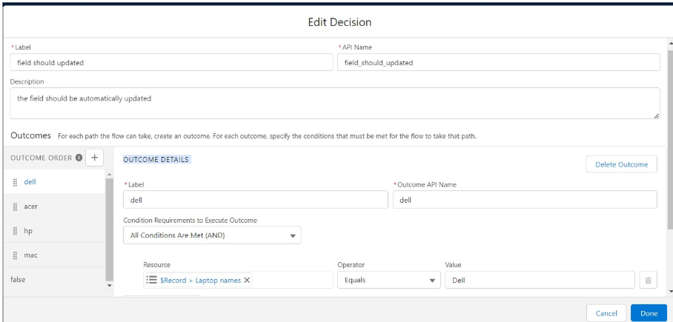

9.Go to flow page. Beside dell there is a symbol ‘+’ click on that.

10.Again select decision

11.Enter the Details Label: Field should Update(any one u want), API name: Gets Automatically Generated.

12.select the Outcome Details Label: dell core i3 , Outcome API name: Gets Automatically Generated.

13.Resource: Select {!$Record.core_type__c}., Operator: Select Equals., Value: Select core i3.

14.Then again click the symbol ‘+’ outcome details

15.select the Outcome ‘+’ Details Label: dell core i5 , Outcome API name: Gets Automatically Generated.

16.Resource: Select Record.core type., Operator: Select Equals., Value: Select core i5.

17.Then again click the symbol’+’ outcome details

18.Enter the Outcome Details Label: dell core i7 , Outcome API name: Gets Automatically Generated.

19.Resource: Select Record.core type., Operator: Select Equals., Value: Select core i7.Click done.

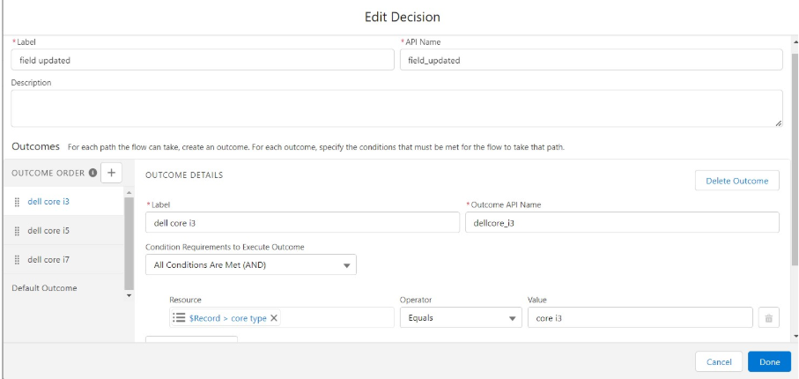

20.So go to the flow page select ‘+’ after core i3 then again select the decision.

21.Enter the Details Label: months selected , API name: Gets Automatically Generated.

22.Enter the Outcome Details Label: dell 1(i3) , Outcome API name: Gets Automatically Generated.

23.Resource: Select Record.how many months., Operator: Select Equals., Value: 1.

24.Enter the Outcome Details Label: dell 2(i3) , Outcome API name: Gets Automatically Generated.

25.Resource: Select Record.how many months., Operator: Select Equals., Value: Select 2..

26.Click ‘+’ outcome details

27.Enter the Outcome Details Label: dell 3(i3) , Outcome API name: Gets Automatically Generated.

28.Resource: Select Record.how many months., Operator: Select Equals., Value: Select 3..

29.Click ‘+’ outcome details. Enter the Outcome Details Label: dell 4(i3) , Outcome API name: Gets Automatically Generated.

30.Resource: Select Record.how many months., Operator: Select Equals., Value: Select 4.

32.Click ‘+’ outcome details. Enter the Outcome Details Label: dell 5(i3) , Outcome API name: Gets Automatically Generated.

33.Resource: Select Record.how many months.,Operator: Select Equals., Value: Select 5.

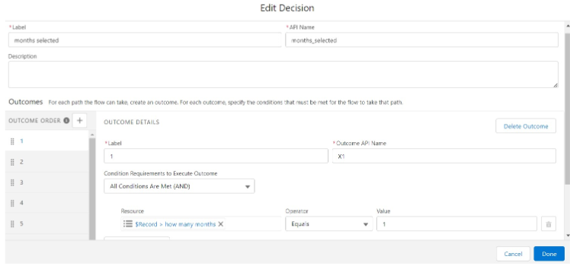

Follow the above picture you will understand.

34.After dell 1(i3) there is ‘+’ symbol like dell 2(i3),dell 3(i3),dell 4(i3),dell 5(i3).

35.Click on ‘+’ then select update records for each and every outcome.

36.Enter the Details Label: one month of dell i3 rate , API name: Gets Automatically Generated. 37.Enter label name in a similar way for other update records.

Field:- Amount__c , value:- for dell 1(i3)-1000, dell 2(i3)-2000, dell 3(i3)-3000, dell 4(i3)-4000, dell 5(i3)-5000. Follow all these finally and update the Amount field value based on the number of months. Click done.

38.Enter the Details Label: months selected , API name: Gets Automatically Generated.

39.Enter the Outcome Details Label: dell 1(i7) , Outcome API name: Gets Automatically Generated.

40.Resource: Select Record.how many months., Operator: Select Equals., Value: 1.

41.Enter the Outcome Details Label: dell 2(i7) , Outcome API name: Gets Automatically Generated. Resource: Select Record.how many months.,Operator: Select Equals.,Value: Select 2.

42.Click ‘+’ outcome details. Enter the Outcome Details Label: dell 3(i7) , Outcome API name: Gets Automatically Generated.

43.Resource: Select Record.how many months., Operator: Select Equals.,Value: Select 3.

44.Click ‘+’ outcome details. Enter the Outcome Details Label: dell 4(i7) , Outcome API name: Gets Automatically Generated.

45.Resource: Select Record.how many months., Operator: Select Equals., Value: Select 4.

46.Click ‘+’ outcome details. Enter the Outcome Details Label: dell 5(i7) , Outcome API name: Gets Automatically Generated.

47.Resource: Select Record.how many months., Operator: Select Equals., Value: Select 5.

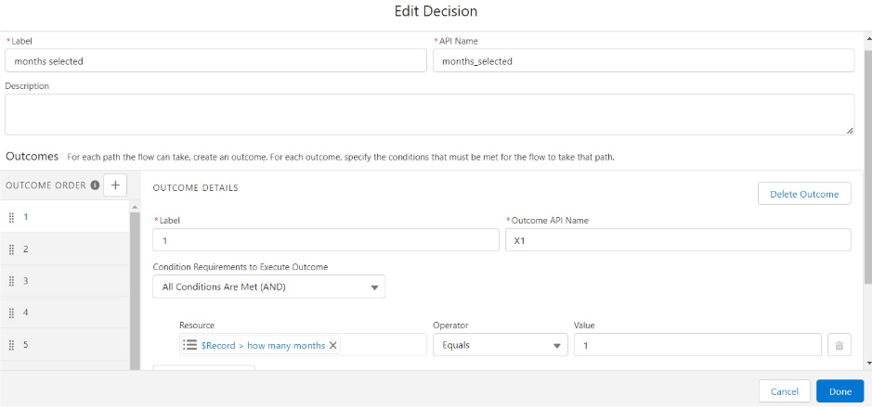

Follow the above picture you will understand.

48.After dell 1(i7) there is ‘+’ symbol like dell 2(i7),dell 3(i7),dell 4(i7),dell 5(i7).

49.Click on ‘+’ then select update records . Enter the Details Label: one month of dell i5 rate , API name: Gets Automatically Generated.

Field:- Amount__c , value:- for dell 1(i7)-2000, dell 2(i7)-4000, dell 3(i7)-6000, dell 4(i7)-8000, dell 5(i7)-10000. Follow for all these finally . Click done.

**Follow the same steps for Dell i5 and update the Amount for each month (1,2,3,4,5) as 1500, 2500,3500,4500,5500 respectively.**

Creating a Flow on Acer laptop

1.Go to flow page

2.Beside acer there is a symbol ‘+’ click on that.Again select decision.

3.Enter the Details Label: Acer core type selection, API name: Gets Automatically Generated.

4.Select the Outcome Details Label: acer core i3 , Outcome API name: Gets Automatically Generated.

5.Resource: Select Record.core type., Operator: Select Equals., Value: Select core i3.

6.Similarly create outcomes for acer core i5 and acer core i7 also. Click done.

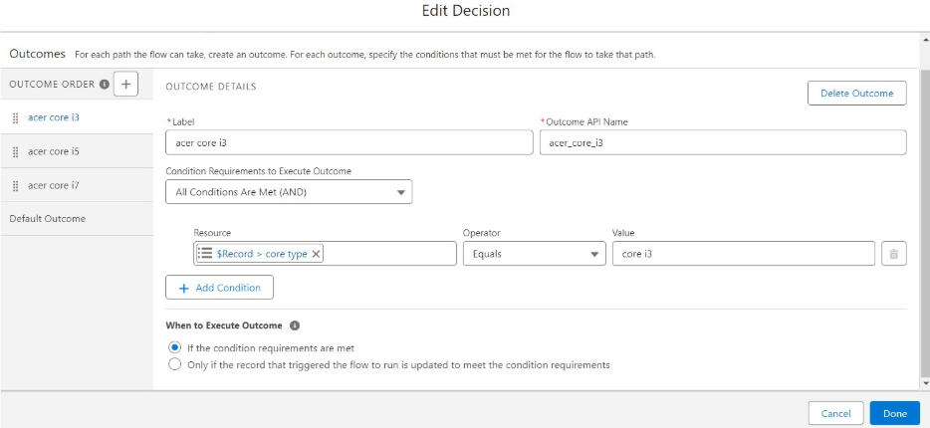

7.Go to flow page Beside dell there is a symbol ‘+’ click on that.

8.Again select decision. Enter the Details Label: Acer months selected , API name: Gets Automatically Generated.

9.Enter the Outcome Details Label: acer 1(i3) , Outcome API name: Gets Automatically Generated.

10.Resource: Select Record.how many months., Operator: Select Equals., Value: 1.

11.Enter the Outcome Details Label: acer 2(i3) , Outcome API name: Gets Automatically Generated.

12.Resource: Select Record.how many months., Operator: Select Equals., Value: Select 2.

13.Click ‘+’ outcome details. Enter the Outcome Details Label: acer 3(i3) , Outcome API name: Gets Automatically Generated.

14.Resource: Select Record.how many months., Operator: Select Equals., Value: Select 3.

15.Click ‘+’ outcome details. Enter the Outcome Details Label: acer 4(i3) , Outcome API name: Gets Automatically Generated.

16.Resource: Select Record.how many months., Operator: Select Equals., Value: Select 4.

17.Click ‘+’ outcome details. Enter the Outcome Details Label: acer 5(i3) , Outcome API name: Gets Automatically Generated. Resource: Select Record.how many months., Operator: Select Equals., Value: Select 5. Click done.

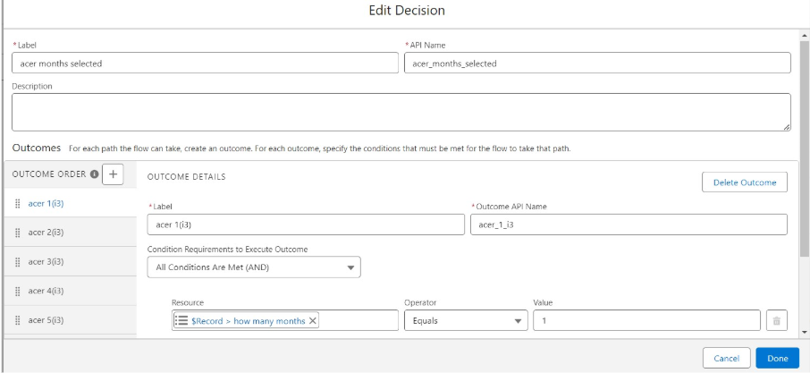

18.After acer 1(i3) there is ‘+’ symbol like acer 2(i3),acer 3(i3),acer 4(i3),acer 5(i3).

19.Click on ‘+’ then select update records. Enter the Details Label: one month of acer i3 rate , API name: Gets Automatically Generated.

20.Field:- Amount__c , value:- for acer 1(i3)-900, acer 2(i3)-1800, acer 3(i3)-2700, acer 4(i3)-3600, acer 5(i3)-4800. Follow for all these finally and click done.

**Follow the same steps and create decision and Update record elements for Acer core i5 and Acer core i7. But enter different Amount values.**

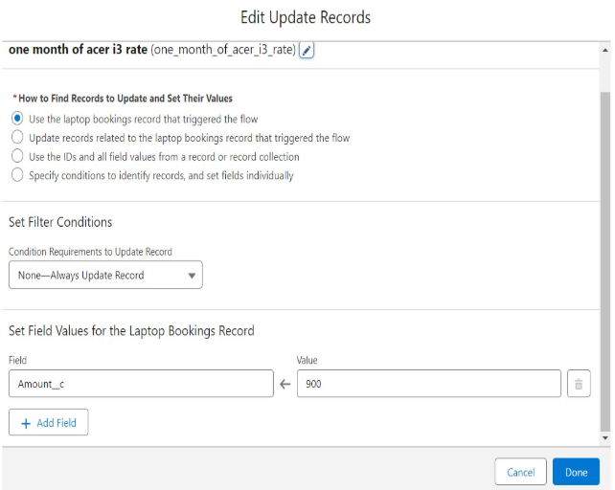

Creating a flow on HP Laptop

1.Go to flow page

2.Beside hp there is a symbol ‘+’ click on that. Again select decision

3.Enter the Details Label: HP core selection, API name: Gets Automatically Generated.

4.select the Outcome Details Label: hp core i3 , Outcome API name: Gets Automatically Generated.

5.Resource: Select Record.core type., Operator: Select Equals., Value: Select hp i3.

6.Similarly create outcomes for hp core i5 and hp core i7 also.

7.Go to flow page

8.Beside hp there is a symbol ‘+’ click on that. Again select decision

9.Enter the Details Label: hp core i5 month selection , API name: Gets Automatically Generated.

10.Enter the Outcome Details Label: hp 1(i5) , Outcome API name: Gets Automatically Generated.

11.Resource: Select Record.how many months., Operator: Select Equals., Value: 1.

12.Enter the Outcome Details Label: hp 2(i5) , Outcome API name: Gets Automatically Generated.

13.Resource: Select Record.how many months., Operator: Select Equals., Value: Select 2..

14.Click ‘+’ outcome details. Enter the Outcome Details Label: hp 3(i5) , Outcome API name: Gets Automatically Generated.

15.Resource: Select Record.how many months., Operator: Select Equals., Value: Select 3..

16.Click ‘+’ outcome details. Enter the Outcome Details Label: hp 4(i5) , Outcome API name: Gets Automatically Generated.

17.Resource: Select Record.how many months., Operator: Select Equals., Value: Select 4.

18.Click ‘+’ outcome details. Enter the Outcome Details Label: hp 5(i5) , Outcome API name: Gets Automatically Generated. Resource: Select Record.how many months., Operator: Select Equals., Value: Select 5. Click on Done.

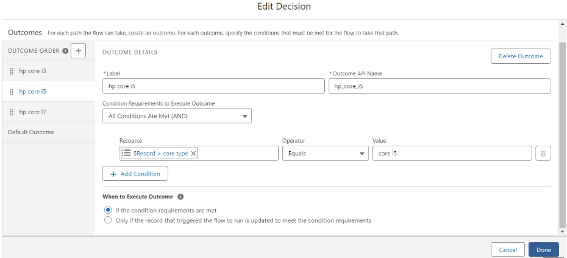

19.After hp 1(i5) there is ‘+’ symbol like hp 2(i5), hp 3(i5), hp 4(i5),hp 5(i5).

20.Click on ‘+’ then select update records . Enter the Details Label: one month of hp i5 rate , API name: Gets Automatically Generated.

21.Field:- Amount__c , value:- for hp 1(i5)-1700, hp 2(i5)-3400, hp 3(i5)-5100, hp 4(i5)-6800, hp 5(i5)-8500. Follow for all these finally and click done.

**Follow the same steps and create decision and Update record elements for Hp core i3 and Hp core i7. But enter different Amount values.**

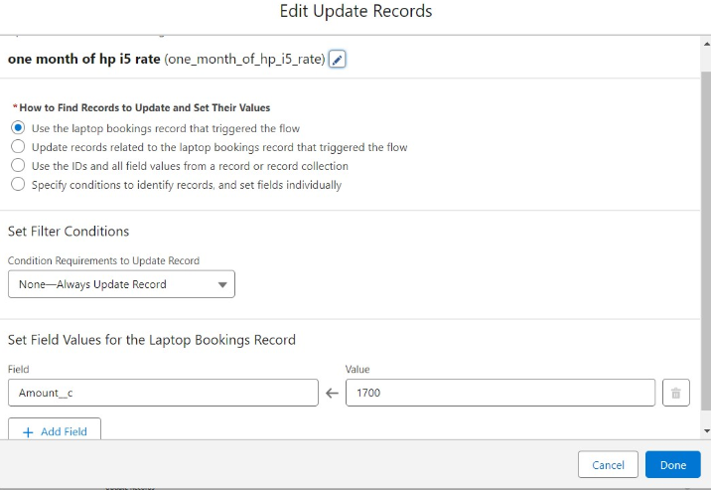

### Creating a flow on MAC Laptop

1.Go to flow page

2.Beside mac there is a symbol ‘+’ click on that. Again select decision

3.Enter the Details Label: mac should be Updated, API name: Gets Automatically Generated.

4.select the Outcome Details Label: mac laptop , Outcome API name: Gets Automatically Generated.

5.Resource: Select Record.core type., Operator: Select Equals., Value: Select Bionic Chip. Click done.

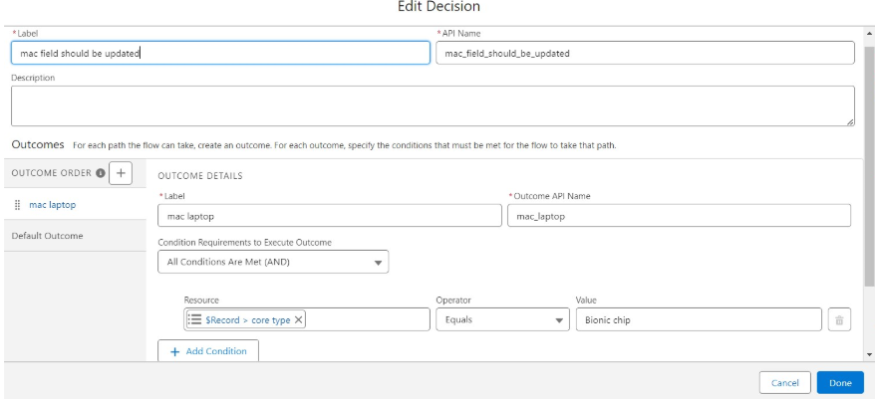

6.Go to flow page

7.Beside Mac there is a symbol ‘+’ click on that. Again select decision

8.Enter the Details Label:Mac months selected , API name: Gets Automatically Generated.

9.Enter the Outcome Details Label: mac bionic chip(1) , Outcome API name: Gets Automatically Generated.

10.Resource: Select Record.how many months., Operator: Select Equals., Value: 1.

11.Enter the Outcome Details Label: mac bionic chip(2) , Outcome API name: Gets Automatically Generated.

12.Resource: Select Record.how many months., Operator: Select Equals.,Value: Select 2.

13.Click ‘+’ outcome details

14.Enter the Outcome Details Label: mac bionic chip(3) , Outcome API name: Gets Automatically Generated.

15.Resource: Select Record.how many months., Operator: Select Equals., Value: Select 3..

16.Click ‘+’ outcome details. Enter the Outcome Details Label: mac bionic chip(4) , Outcome API name: Gets Automatically Generated.

17.Resource: Select Record.how many months., Operator: Select Equals., Value: Select 4.

18.Click ‘+’ outcome details

19.Enter the Outcome Details Label: mac bionic chip(5) , Outcome API name: Gets Automatically Generated.

20.Resource: Select Record.how many months., Operator: Select Equals., Value: Select 5. Click done.

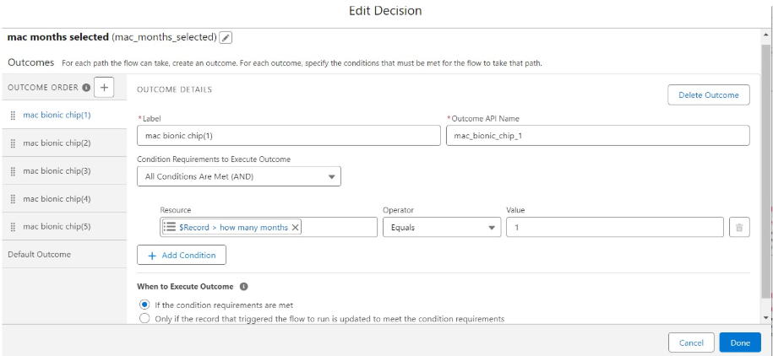

21.After mac bionic chip(1) there is ‘+’ symbol like mac bionic chip(2), mac bionic chip(3), mac bionic chip(4),mac bionic chip(5).

22.Click on ‘+’ then select update records. Enter the Details Label: one month of mac rate , API name: Gets Automatically Generated.

23.Field:- Amount__c , value:- for one month of mac bionic chip rate-1700, two month of mac bionic chip rate-3400, three month of mac bionic chip rate-5100, four month of mac bionic chip rate-6800, five month of mac bionic chip rate-8500. Follow for all these finally click on done.

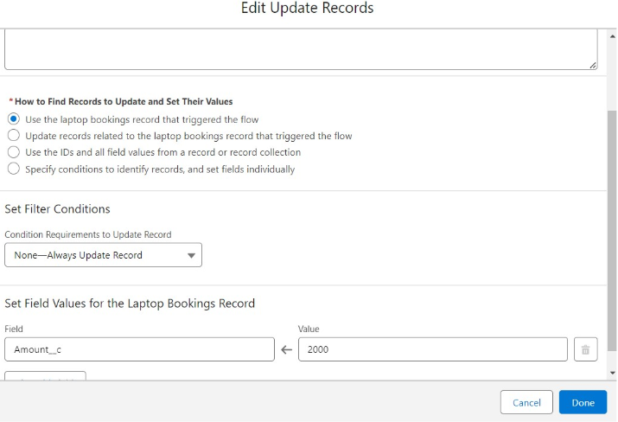

Click on save. Label:- Laptop distributions, api name:- automatically filled

Save the flow and activate it.

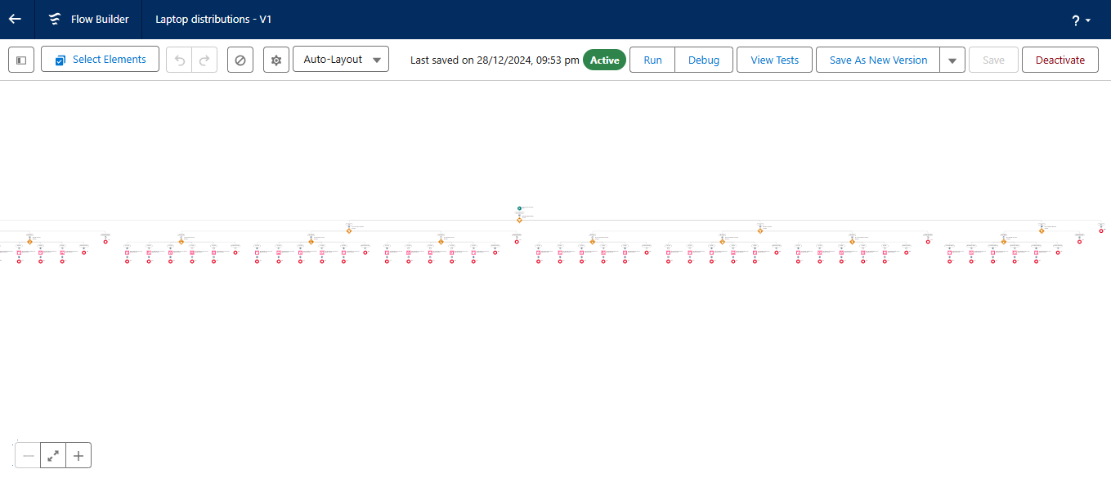

APEX

### Apex Trigger and Handler Class

**How to create a new trigger :**

1.While still in the trailhead account, navigate to the gear icon in the top right corner. Click on developer console and you will be navigated to a new console window.

2.Click on the File menu in the toolbar, and click on new? Trigger.

3.Enter the trigger name and the object to be triggered.

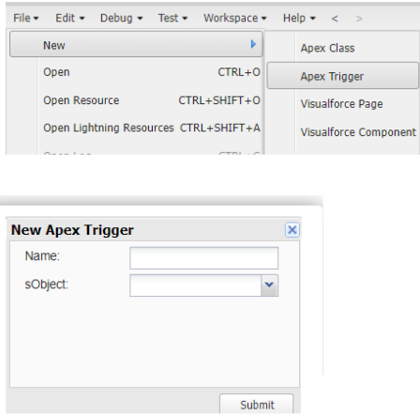

**Note:-** copy the API names

1.LaptopBooking - trigger name

2.Laptop_Bookings__c -as per your org(go to laptop bookings object and copy from that object api name).

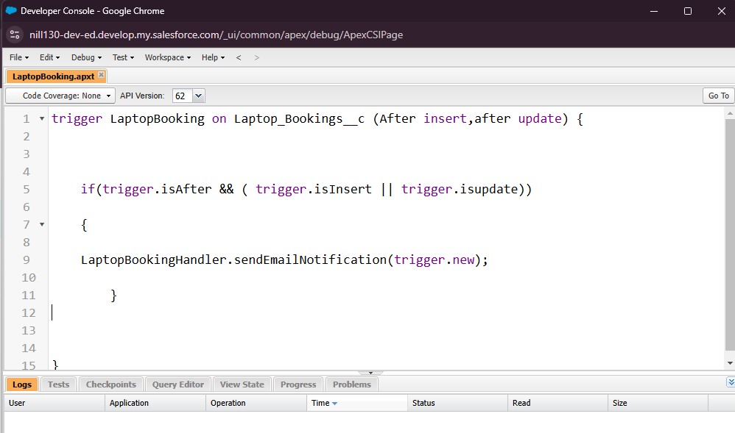

**Handler Class:**

**Note:-** 1.Class name:- LaptopBookingHandler

2.API Name:- Laptop_Bookings__c(as per your org go to laptop booking object and copy from that).

3.core__c (as per your org go to laptop booking object and copy from that).

4.Laptop_type__c.(as per your org go to laptop booking object and copy from that).

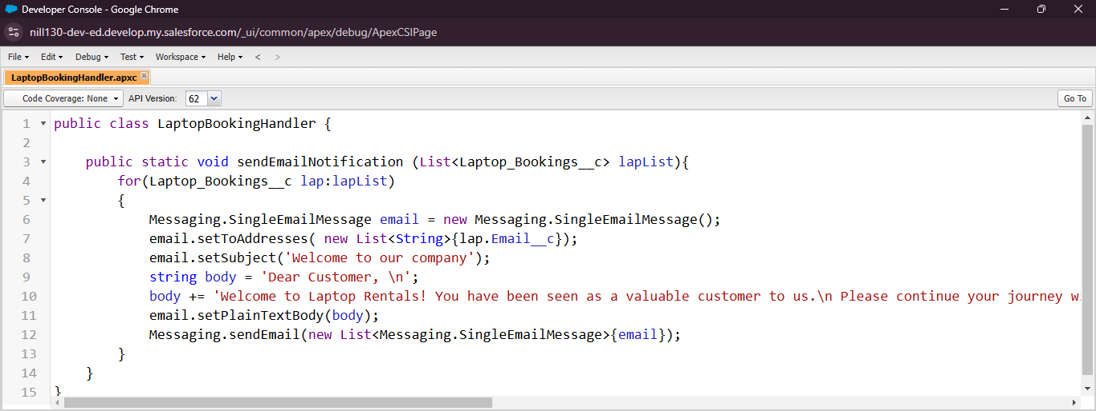

### Reports

### Create Report

**Note: Before creating reports just fill the 10-12 records in the Laptop Bookings object.**

**Create records for each one you have to create at least 2 different records i.e dell(i3), dell(i7),acer(i3),hp(i5),mac(bionic chip).**

1.Go to the app ? click on the reports tab.

2.Click New Report.

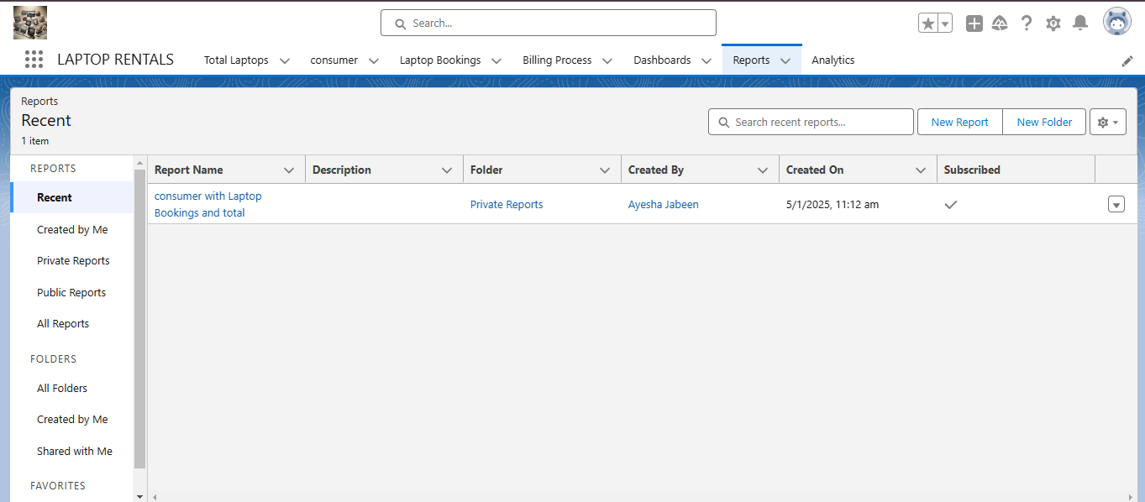

3.Select report type from category or from report type panel or from search panel “consumer with Laptop Bookings and total laptops” ? click on start report.

4.Create a simple tabular report. Add fields from left pane, make sure that Amount field will be selected.

5.Click the Amount column drop down and select bucket list. Click Apply.

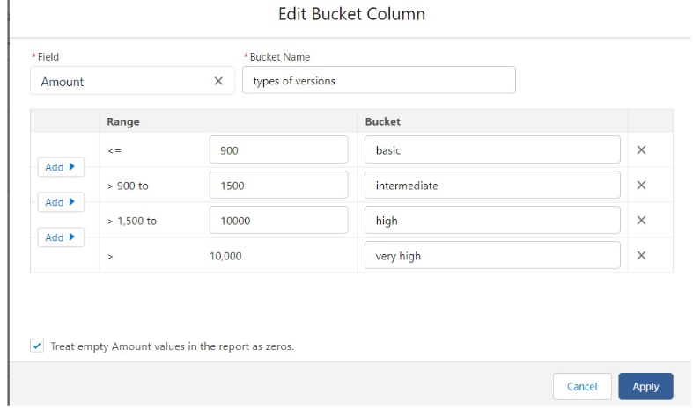

6.Select Types of version in Group By Rows to create a summary report. Follow the image for other fields. Click on Save and Run it.

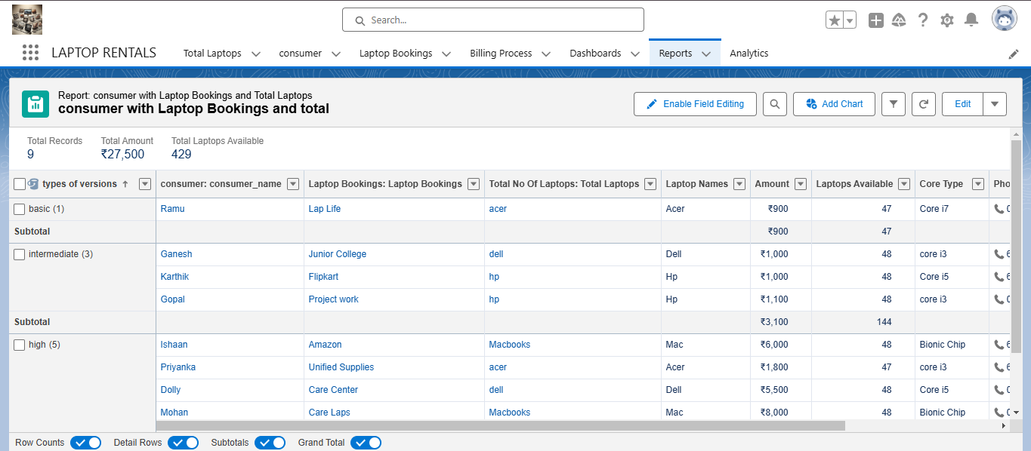

### Sharing report to owner

1.Click edit drop down and select subscribe option

2.Follow as per below image.

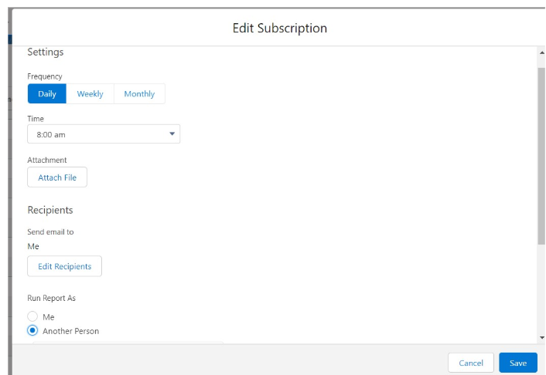

3.After selecting the run report as a “another person” select your personal account or whom you want to send that mail to. Click save.

**NOTE: The owner gets daily email notification of that laptop booking report.so that he can see all data remotely.**

Result:

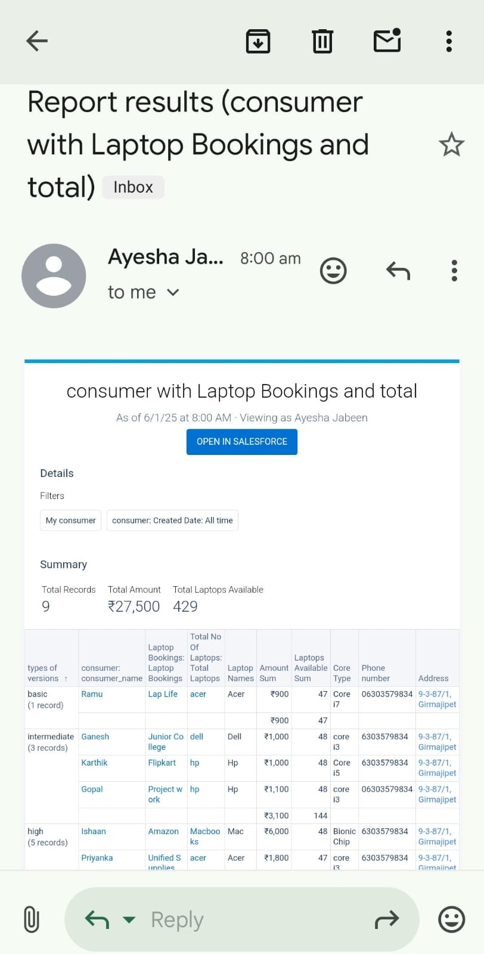

### Dashboards

### Create Dashboard Folder

1.Click on the app launcher and search for the dashboard.

2.Click on the dashboard tab.

3.Click the new folder, give the folder label as “total rent amount”.

4.Folder unique names will be auto populated. Click save.

### Create Dashboard

1.Go to the app >> click on the Dashboards tabs.

2.Give a Name and select the folder that was created, and click on create.

3.Select add component.

4.Select a Report and click on select.

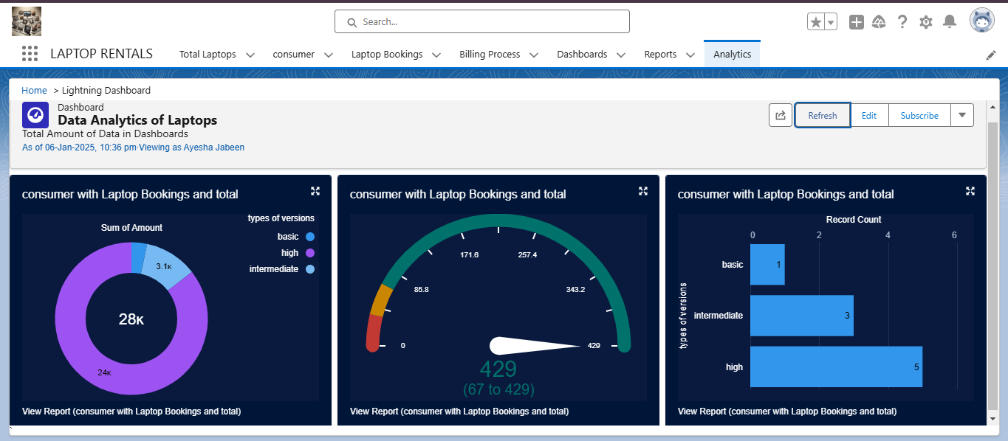

5.Select the dark component and add to the dashboards.

6.Save it.

7.Click done.

5. Testing and Validation

1.Class name:- LaptopBookingHandler

2.API Name:- Laptop_Bookings__c(as per your org go to laptop booking object and copy from that).

3.core__c (as per your org go to laptop booking object and copy from that).

4.Laptop_type__c.(as per your org go to laptop booking object and copy from that).

**Apex Class Code:**

public class LaptopBookingHandler {

public static void sendEmailNotification (List<Laptop_Bookings__c> lapList){

for(Laptop_Bookings__c lap:lapList)

{

Messaging.SingleEmailMessage email = new Messaging.SingleEmailMessage();

email.setToAddresses( new List<String>{lap.Email__c});

email.setSubject('Welcome to our company');

string body = 'Dear Customer, \n';

body += 'Welcome to Laptop Rentals! You have been seen as a valuable customer to us.\n Please continue your journey with us, while we try to provide you with good quality resources. \n Laptop Amount = ' + lap.Amount__c + ' \n core type = '+lap.core_type__c +' \n Laptop type = '+lap.Laptop_name__c;

email.setPlainTextBody(body);

Messaging.sendEmail(new List<Messaging.SingleEmailMessage>{email})}}}

**Apex trigger Code:**

trigger LaptopBooking on Laptop_Bookings__c (After insert,after update) {

if(trigger.isAfter && ( trigger.isInsert || trigger.isupdate))

{

LaptopBookingHandler.sendEmailNotification(trigger.new);

}

}

**Unit Testing:**

Apex classes and triggers were validated to ensure error-free email notifications.

Roll-up summary and formula fields were tested for accurate calculations.

**User Interface Testing:**

Verified functionality of page layouts, ensuring seamless navigation and usability.

Ensured accurate rendering of reports and dashboards.

**End-to-End Testing:**

Simulated daily workflows, including data entry, report generation, and dashboard updates, to validate system reliability.

Tested role-based access controls to ensure proper data visibility and security.

**6. Key Scenarios Addressed by Salesforce in the Implementation Project**

**Daily Reporting:**

Automating the generation of daily sales and revenue reports for the owner.

**Role-Based Data Access:**

Providing tailored access to data based on user roles.

**Enhanced Customer Engagement:**

Sending email notifications to customers with details of their purchases and payments.

**Data Integrity:**

Ensuring data consistency and reliability through validation rules and error handling.

**Business Insights:**

Delivering actionable insights through reports and dashboards, enabling data-driven decisions.

### 7. Conclusion

**Summary of Achievements:**  
The Laptop Rentals CRM Application successfully streamlined and enhanced the laptop rental business’s operational processes. Key achievements include:

● **Operational Efficiency:**  
○ Optimized workflows and improved inventory management through automated data handling and tracking of rental transactions.

● **Data Visualization:**  
○ Created dynamic reports and dashboards to provide real-time insights into inventory utilization, revenue trends, and rental durations.

● **Enhanced Security:**  
○ Implemented robust role-based access controls and field-level security to ensure data confidentiality and integrity.

● **Improved Customer Communication:**  
○ Automated email notifications for rental confirmations, due date reminders, and follow-up communications, enhancing customer engagement and satisfaction.

● **Scalability:**  
○ Developed a scalable and modular solution using Salesforce's flexible architecture, allowing easy adaptation for future business growth and feature enhancements.

The Laptop Rentals CRM Application demonstrates the transformative potential of Salesforce in addressing industry-specific challenges. By automating processes, improving customer experiences, and enabling insightful decision-making, the solution has paved the way for operational excellence and sustainable growth in the laptop rental business.